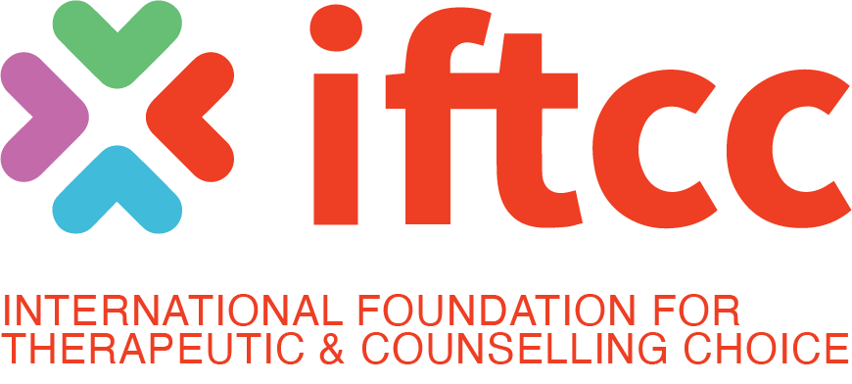

IFTCC Statement Following the PSA Appeal Outcome 22 June 2026

The International Foundation for Therapeutic and Counselling Choice (IFTCC) notes the decision of the Professional Standards Authority (PSA) to reject its appeal and refuse accreditation of the proposed IFTCC register.

The IFTCC entered the accreditation process seeking to establish a framework of professional standards, supervision, safeguarding, accountability, ethical oversight, continuing professional development, and complaints procedures for practitioners working with individuals who voluntarily seek support consistent with their own values, beliefs, and life goals.

The Appeal Panel acknowledged that the IFTCC rejects coercive and aversive practices, accepted that Clinical Practitioners were eligible in principle for accreditation, recognised the contribution of Pastoral Care Workers, and accepted that some individuals report benefit from such support. The PSA nevertheless concluded that the available evidence did not provide sufficient assurance for accreditation.

The PSA has therefore declined to endorse the framework proposed by the IFTCC. That decision concludes a lengthy 28-month process of application, appeal, reassessment, and further appeal. It does not remove the questions that gave rise to the application.

Across many nations, individuals continue voluntarily to seek support in addressing conflicts involving sexuality, gender identity, faith, relationships, personal history, and deeply held convictions. Practitioners continue to provide that support. The need for safeguarding, accountability, supervision, and professional standards has not disappeared.

As governments and regulators continue to consider legislative and regulatory developments in this area, the central question remains: how are those seeking such support to be served, protected, and safeguarded, and how are practitioners working in this field to be supervised, guided, and held accountable?

The IFTCC sought to provide one answer to that question through a framework of voluntary regulation. The PSA has declined to endorse that framework.

This is a contested field. The IFTCC believes that disagreement is not an argument against accountability. It is an argument for it. The PSA accepted that the IFTCC rejects coercive and aversive practices, yet declined to accredit the framework through which practitioners would be supervised, accountable, and subject to professional standards.

A framework of accountability has been rejected. No alternative framework has been offered. Yet the individuals seeking support remain. So too do the clinicians, counsellors, pastoral care workers, and others seeking to serve them responsibly within accountable standards of practice.

For the IFTCC, the focus now moves beyond accreditation. The organisation will continue its international work in education, research, scholarship, professional collaboration, standards development, and ethical practice through its conferences, learning programmes, publications, research initiatives, and professional networks.

The International Foundation for Therapeutic and Counselling Choice (IFTCC) is an international project of Core Issues Trust, a UK-registered charity (NI 105095). The IFTCC supports professionally qualified practitioners, including clinicians, counsellors, pastoral care workers, educators, and researchers, who seek to provide accountable, ethical, professionally supervised support to individuals pursuing goals consistent with their own values, beliefs, and life convictions.

Further information or interview
Dr Mike Davidson mike.davidson@iftcc.org
Chairman IFTCC, CEO Core Issues Trust
+44 07833098998

